

**PES UNIVERSITY**

**Course Title:**UE23CS242A: Web Technologies

**Semester: III**

**Credits:4**

**Course Type: Core / Elective / Special Topic:Core**

**Experiential Learning (2025-26):**

**(Banana problem) Level -1**

**ProblemStatement:**

During the PES University (PESU) admission process, applicants are required to submit personal profiles. Existing online forms lack interactivity, real-time validation, and live previews, often leading to user errors and poor experience. A smart, responsive form with dynamic feedback and validation is essential to improve accuracy, usability, and user engagement.

**HTML5 (Hypertext Markup Language),CSS3 (Cascading Style Sheets),JavaScript (Client-side Scripting),Form Validation Techniques,User Interface (UI) & User Experience (UX) Design,Responsive Web Design,Date and Time Handling** and **Flexbox** – For responsive layout

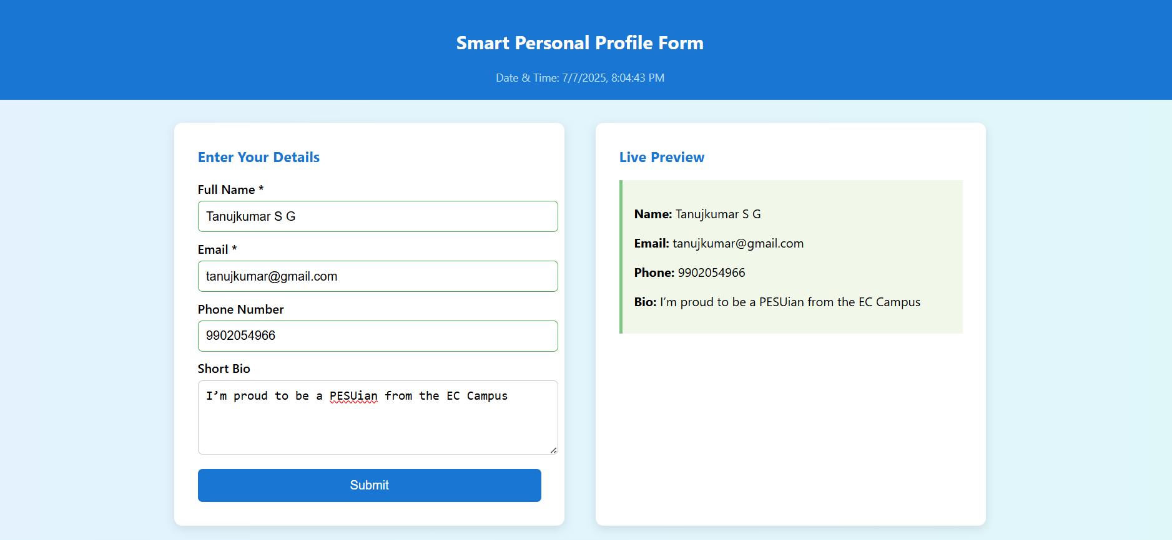

Rubrics:

| HTML | 3 marks |
| --- | --- |
| CSS (UI/UX) | 3 marks |
| Javascript | 4 marks |
| Total | 10 marks |